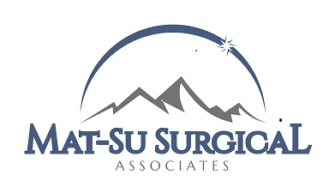
GARTH LeCHEMINANT, M.D.
DAVID MORROW, M.D.
JENNIFER LEMERT, APRN

2490 S. WOODWORTH LOOP, STE 450
PALMER, AK 99645
__

Phone: (907) 745-8100
Fax: (907) 746-2655

Dear Patient:

Physicians have always protected the confidentiality of health information by sealing medical records away in file cabinets. Today, state and federal laws also attempt to ensure the confidentiality of this sensitive information. The federal government has published regulations designed to protect the privacy of your health information (HIPAA – Health Insurance Portability and Accountability Act). This “privacy rule” protects health information that is maintained by physicians, other health care providers and health plans.

This regulation protects virtually all patients regardless of where they live or where they receive their health care. Every time you see a physician, the hospital or other health care provider will need to consider the privacy rule. All health information including paper records, oral communications, and electronic formats are protected by the privacy rule.

The privacy rule also provides you certain rights, such as the right to have access to your medical records. The Notice of Privacy Practices attached to this letter explains our privacy practices. It contains very important information about how your confidential health information is handled by our office. It also describes how you can exercise your rights with regard to your protected health information.

Please let us know if you have any questions about our Notice of Privacy Practices. You may contact our Privacy Officer at 745-8100.

Sincerely,

Tonya Media
Privacy Officer

